RISC-V VeeR EL2 Based Real-Time Data Buffering SoC
1. Block Diagram
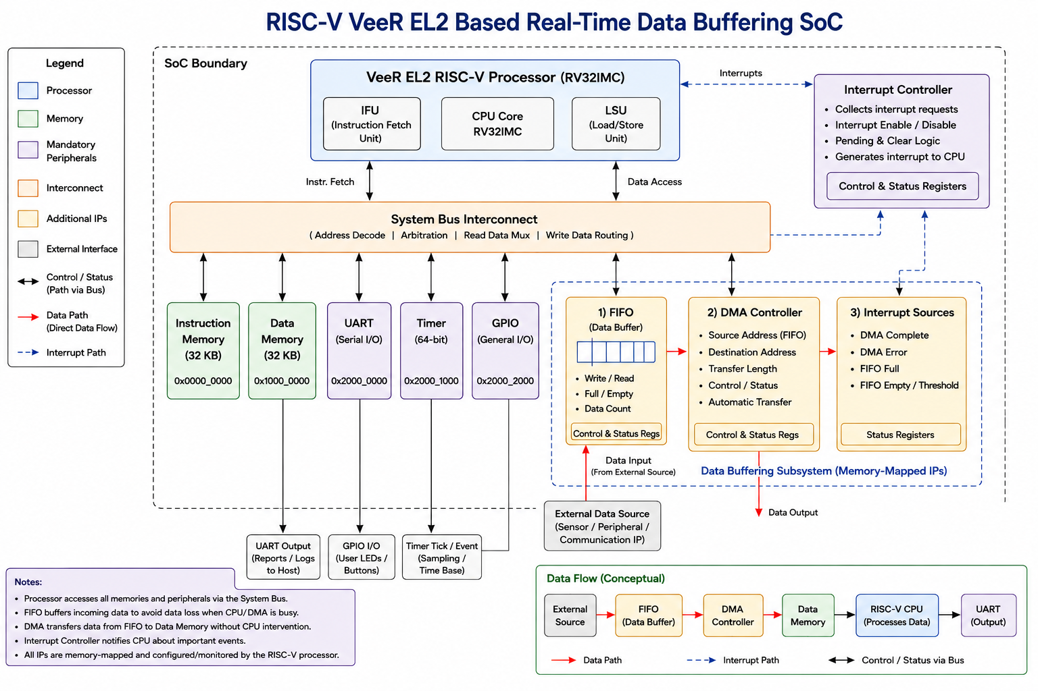

2. Application and Signal Flow
Application: Real-Time Industrial Motor Vibration Monitoring using a 3-axis accelerometer. The accelerometer provides continuous vibration samples to the SoC, which buffers incoming data in the FIFO, transfers data blocks to Data Memory through the DMA Controller, and allows the RISC-V processor to analyze the samples and report abnormal vibration through UART.
Data Flow: External Vibration Sensor → FIFO → DMA Controller → Data Memory → RISC-V Processor → UART
Control Path: RISC-V Processor → System Bus → FIFO / DMA Controller / Interrupt Controller
Interrupt Path: FIFO / DMA Events → Interrupt Controller → RISC-V Processor
UART Output Path: RISC-V Processor → UART → External Host/PC
3. External → SoC Signals
Signal | Direction | Width | External Source | Purpose
clk | External → SoC | 1 | External clock | System clock for all SoC logic
reset_n | External → SoC | 1 | External reset | Resets the SoC
data_in[31:0] | External → SoC | 32 | Vibration data source / testbench | Incoming real-time sample data to FIFO
valid_in | External → SoC | 1 | Vibration data source / testbench | Indicates valid sample data
gpio_in[7:0] | External → SoC | 8 | External digital source | GPIO input signals
uart_rx | External → SoC | 1 | Host / external device | UART serial input
4. SoC → External Signals
Signal | Direction | Width | External Destination | Purpose
data_ready | SoC → External | 1 | External vibration data source | Indicates FIFO can accept a new sample
uart_tx | SoC → External | 1 | Host / PC | Reports transferred data and vibration status
gpio_out[7:0] | SoC → External | 8 | External device / status LEDs | Digital output or status indication
Selected Real-Time Data Source: 3-axis accelerometer attached to an industrial motor. For RTL verification, the accelerometer output is modeled by the testbench using the same data_in/valid_in interface.

